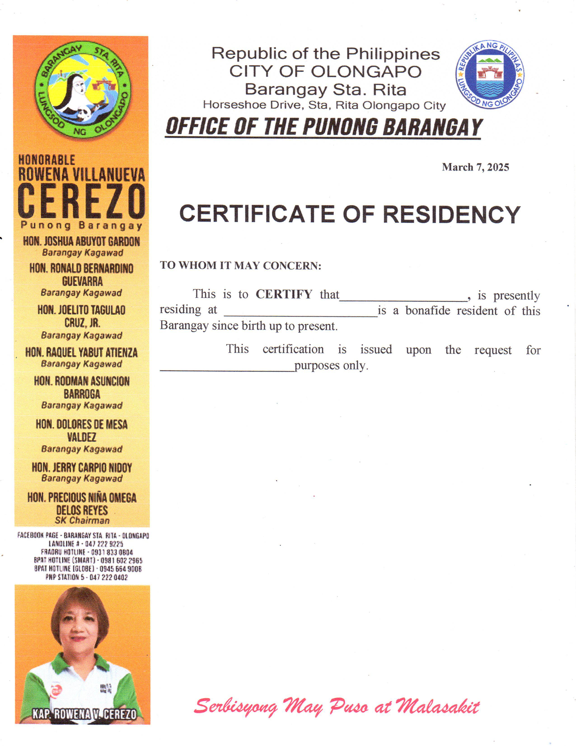 Republic of the Philippines CITY OF OLONGAPO Barangay Sta. Rita Horseshoe Drive, Sta. Rita Olongapo City ***OFFICE OF THE PUNONG BARANGAY***

**{dateRequested}**

BARANGAY CERTIFICATION

**TO WHOM IT MAY CONCERN:**

This is to **CERTIFY** that **{honorifics}.** {fullName} of legal age, presently residing at {address} is a bonafide resident of this Barangay since birth up to present.

 Further CERTIFY that {fullName}, is a **FIRST TIME JOB SEEKER** after graduating from {schoolName}.

This **CERTIFICATION** is issued upon the request of {purpose}, for whatever legal purposes only